

Posada Los Ninos Orphanage
Volume 1, Issue 1
October, 2009

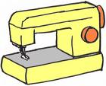
Our young ladies had a fun and valuable project this summer with the help of two wonderful girls from Colorado, Morgan and McKinley. The cousins, accompanied by Morgan’s Mom, Hollee and their grandmother Vikki who also lent a hand.
The girls brought all of the instructions, fabric and supplies with them for the projects.
Our young ladies completed tote bags for their personal use. Each girl had to finish her own project. The project was so fun that some girls made multiple bags.
All of the projects are chosen with the thought in mind of giving the girls a skill or activity that they could use eventually to bring in some money for their personal use.
Rhonda has picked some additional projects that will follow up on the sewing skills acquired during the summer project.
In October, the girls will learn how to make quilted wallets. They will again be able to keep the projects they complete.
In November, a manicurist will teach how to do a proper manicure and pedicure. Each girl will be given the necessary supplies.
All of the items given to the girls are collected from donations received from their supporters in the area and throughout North America.
We want the young ladies to be equipped to face the world as they are becoming of age to leave the care of the orphanage.

Fun Projects teach Life Skills
Inside this issue:
Caring Hearts

December Project and Holiday plans
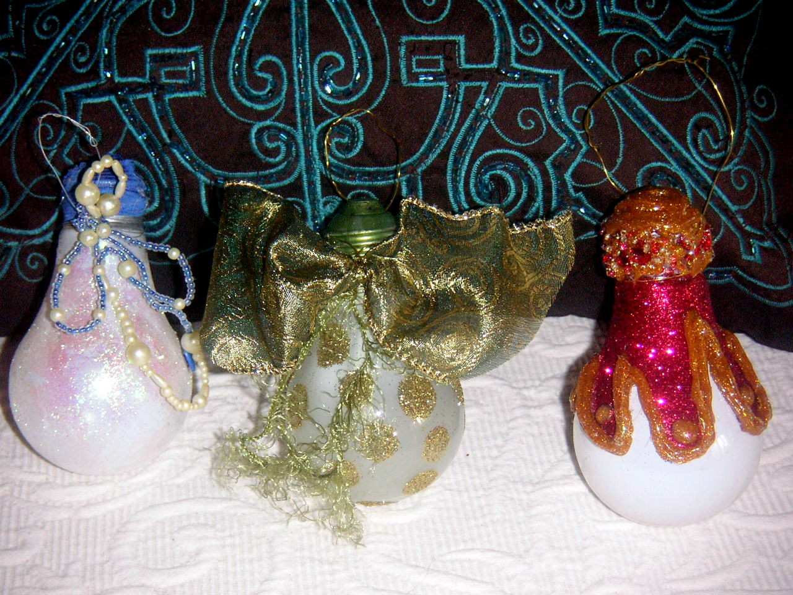

A delightful Christmas ornament is going to be the project for the girls in December. The project was chosen because the base of the ornament is a burnt out light bulb which is a great way to recycle and relatively easy to find for the girls. It’s important that the project not be too costly that the girls would not be able to afford the elements.
For our local friends, please keep your light bulbs that might no longer work. We will arrange to get them from you.

story. Develop the headline before you write the story. This way, the headline will help you keep the story focused.
Examples of possible headlines include Product Wins Industry Award, New Product Can Save You Time!, Membership Drive Exceeds Goals, and New Office Opens Near You.
About the Girls 2
Project History 2
Please Help 3
Pacific Lots 3
Introducing Jan 3
Call out to Special People 4
There are normally between 6 to 8 girls in the orphanage of Posado del Nino. They range in age from 14 to 18. Most of the young ladies are in this home because they have special needs.
Although their background is never revealed for their privacy, some of the girls have learning disabilities or are autistic.
Each girl has had something in their past that has necessitated that they leave their family to live in this facility. In the Costa Rican society, family is extremely important and integral to an individual. It is very hard for the girls.
One of our young ladies has decided that she would like to be a baker upon completion of school. So a cake decorating class, decorating tools and baking equipment were located and given to support her endeavor.
Another child would like to be a dolphin trainer. Attempts to find someone locally to give her more information will be found.
Some young ladies will be relocated to another facility when they reach 18 and cannot enter society. Each one is lovely and deserves the best we can find for them.

About the girls in need….

Rhonda Bulkley is a beautiful, vivacious person. In addition to being able to charm anyone that meets her, she is a person who is dedicating this phase of her life to something truly meaningful, the help and service of others.
I met Rhonda for the first time earlier this month. I wanted to learn more about what she was doing to help a specific group of people, the girls at Posado del Ninos, who might otherwise go somewhat unnoticed.
Rhonda told me about the roots of the project and the hurdles she climbed to be able to visit the girls. A very detailed plan outlining her objectives and tactics was translated and presented to Costa Rican Child Protective Services. The Costa Rican government has put safe guards in place to protect the young ladies.
Fast-forward a year and Rhonda was given access to the girls with the absolute highest needs. It is truly a testament to her intense desire to ensure that each girl that is able to leave the orphanage obtains skills that would not force her into a life on the streets.
Rhonda’s commitment to the girls is profound. In addition to all of the time it takes to set up the projects, acquire the materials, get translations into Spanish, much of the cost is funded by her. She is definitely a “put your money where your mouth is” type person.
Her determination to make her visit, not only fun but educational has made such a difference in the girls lives that one girl confided to her social worker that she wished Rhonda was her mother. Rhonda said, “I was so touched, tears came to my eyes.”
Rhonda’s goal to help just a couple of girls has definitely been realized but that only means now that the dream will grow.
The long range goal is to have a halfway house to assist the girls as they become of an age that they must leave. Currently once a girl comes of age she has no where to go. How tragic to not have a way to move back into society after already being dealt such a bad hand.

History of Rhonda’s Project

““I was so touched, tears came to my eyes.”
Caring Hearts
Page 2
“Helping the young ladies of Posada del Ninos is exactly why I traded in my 9-5 job.”
Caring Hearts
Page 3
Christmas is an especially important time for many of us. It is thought to be a time to spend with family and friends, We exchange gifts and cards to tell others how important they are to us.
In the home of our girls, we really want to stress to them that there are people who love and care for them. It is a hard time of year for those that have no family so we need your help.
We would like to give each young lady some presents to open. We need stocking stuffers, jewelry, small purses, toiletries, etc.
For our friends in the area, we will collect these items at the Uvita market on the last two Saturdays of November.
For our North American friends, we will try to arrange to have you mail your donations to someone that is coming to Costa Rica.
Mailing items here is possible but it takes a little extra effort to get them through customs without being pilfered.
Monetary donations are also welcome which would allow for us to buy things locally for our girls.
If you can help, please contact Rhonda or Jan. Their information is on the last page of the newsletter.

We need your help!
One of our biggest supporters is Kristina Welburn from Pacific Lots. Pacific Lots is a marketing, real estate company that sells property in the Ventanas del Pacifico developments.
Kristina’s company writes a quarterly newsletter to owners and potential buyers on what is happening in the Ojochal area.
She also is a staunch supporter of the orphanage. Each trip down she will bring supplies or gifts for our girls. Kristina said, “I'm also happy to be part of an undertaking that will not only change the lives of numerous children but will ripple through the community. In changing one life you are indirectly influencing a multitude.”
Kristina, we cannot thank you enough for positively impacting our efforts!

Thank You Pacific Lots

Jan Dwire recently joined the ranks to help Rhonda with the projects and needs of Posada del Nino.
Jan moved to Ojochal with her husband, Ross and two cats in June of this year. After spending 25 years in the corporate world of hospitality, travel and airline industries, she determined that she wanted a change. With a background in marketing and eCommerce, Jan is hoping to help with her business skills
Jan sought out Rhonda after hearing from many in the area about what wonderful work she is doing. Jan said, “Coming to Costa Rica is amazing but to add to that helping the young ladies of the Posada del Nino is exactly why I traded in my 9 – 5 job.

Introducing Jan

Posada del Ninos
We are constantly amazed at the generosity of others. It is particularily rewarding to see on the front line that the money and goods donated go directly to help the young ladies. Nothing is taken from the coffers to support the “not for profit” organization.
The orphanage also receives assistance from larger groups such as the Peace Corp. Peace Corp volunteers have been asked to support our projects and programs so that the children get comfortable with a set group of people.
We truly want to thank certain individuals that have been there to support the endeavors from the beginning. We especially would like to acknowledge Jimmy Umana. Jimmy gives countless hours translating the materials and proposals into Spanish. Without his help we couldn’t do many of the projects. Jimmy, a heartfelt Thank You!

Help comes from so many
Rhonda’s Phone
506- 2276-5346
E-mail
rhondabulkley@live.com

Jan’s Phone
506-8951-3391
(416) 273-5663
E-mail jan.dwire@ymail.com

It is all about caring!
T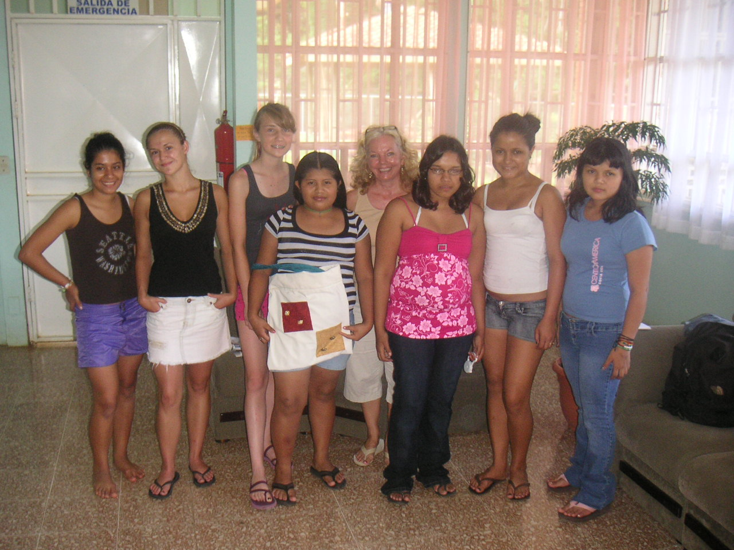Please help these wonderful young ladies during their teen years.
Our website will be coming soon!
Caring Hearts
Page 4

